Steak & Potatoes
By Angelo in Toronto

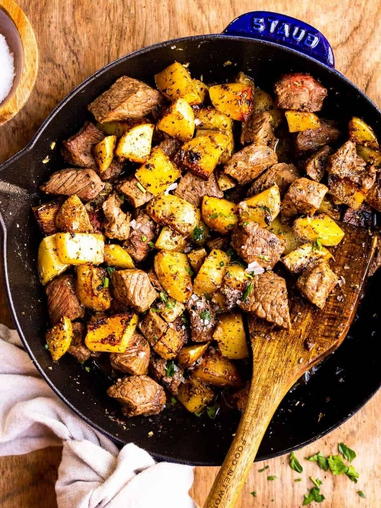
Supplies You’ll Need
- 1 tablespoon olive oil
- 4 tablespoons unsalted butter divided (½ stick)
- 1 pound Yukon Gold potatoes diced into ½-inch cubes
- 4 cloves garlic minced
- 1 teaspoon dried rosemary
- 1 teaspoon dried oregano
- ½ teaspoon kosher salt
- ½ teaspoon ground pepper
- 1½ pounds sirloin steak cut into 1-inch cubes
- Freshly chopped parsley optional, for garnish

Making the Magic Happen
- Heat a cast iron skillet over medium-high heat. Add the olive oil and 2 tablespoons of the butter. Let the butter melt completely. (4 tablespoons unsalted butter,1 tablespoon olive oil)
- Add the cut potatoes, garlic, rosemary, oregano salt, and pepper. Cook for approximately 4 minutes without disturbing. Stir and cook an additional 3-4 minutes, or until fork tender. Remove the potatoes from the pan and set aside in a bowl. (1 pound Yukon Gold potatoes,4 cloves garlic,1 teaspoon dried rosemary,1 teaspoon dried oregano,½ teaspoon kosher salt,½ teaspoon ground pepper)
- Return the skillet to the stove and increase the heat to high. Add 2 tablespoons of butter and stir to melt. Add the steak bites in a single layer and cook for 1 minute. Flip or stir the steak for another 1-2 minutes, or until desired doneness. Remove the skillet from the heat. (4 tablespoons unsalted butter,1½ pounds sirloin steak)
- Add the cooked potatoes back to the skillet and toss together. Add additional salt and pepper if desired.
- Top with fresh chopped parsley (optional). (Freshly chopped parsley)
- Enjoy!

