**Maple Pecan Cookie Pie**

By Ella in New York

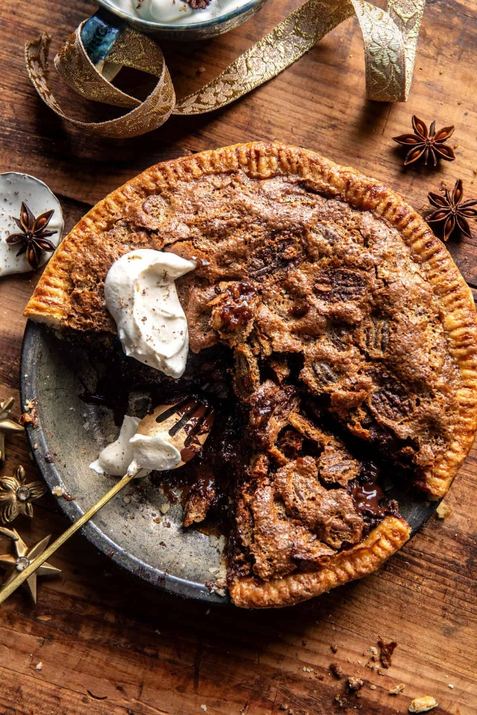**Supplies You’ll Need**

* 1 1/2 cups raw pecans
* 1/2 cup maple syrup
* 1/4 cup bourbon *(optional)*
* 2 tablespoons brown sugar
* flaky sea salt
* 1 pie crust round
* 1 egg *beaten for brushing*
* vanilla sugar or coarse sugar, for sprinkling *(optional)*
* 4 tablespoons salted butter
* 1 cup brown sugar
* 2 large eggs, at room temperature
* 1 egg yolk, at room temperature
* 1/3 cup heavy cream
* 2 teaspoons vanilla extract
* 1 cup semi-sweet chocolate chips or chunks

**Making the Magic Happen**

1. Position a rack in the lower third of the oven. Preheat the oven to 350° F. Line a baking sheet with parchment paper.
2. In a pot, combine the pecans, maple syrup, and bourbon (if using). Simmer over medium heat for 5 minutes. Remove from the heat. Strain the pecans away from the syrup and place on the prepared baking sheet. Set the syrup aside to use in the pie.
3. Toss the pecans with 2 tablespoons brown sugar. Bake for 10 minutes, until toasted. Remove from oven and sprinkle lightly with sea salt (if desired). Let cool, then lightly chop.
4. Fit the pie crust into an 8-inch pie plate. Brush the edges of the crust with beaten egg, then sprinkle with vanilla sugar (or coarse sugar). Lightly prick the bottom of the dough with a fork. Freeze for 10 minutes.
5. Meanwhile, add the butter to a small saucepan set over medium heat. Cook until the butter begins to brown, about 3-4 minutes. Remove from the heat.
6. Whisk together 1 cup brown sugar, 2 eggs, and 1 egg yolk until well combined. Add the 1/3 cup of the reserved maple syrup mix and the cream. Whisk in the brown butter and vanilla until smooth. Fold in the pecans and chocolate. Pour the mixture into the crust.
7. Bake for 55-60 minutes until the pie is puffed on top but still wiggly in the center. The longer you bake, the more set your pie will be. Remove from the oven and let cool for 20-30 minutes. Serve the pie warm and dolloped with whipped cream. Or serve at room temp.
8. Enjoy!