**Butterscotch Monkey Bread**

By Lila in Saskatoon

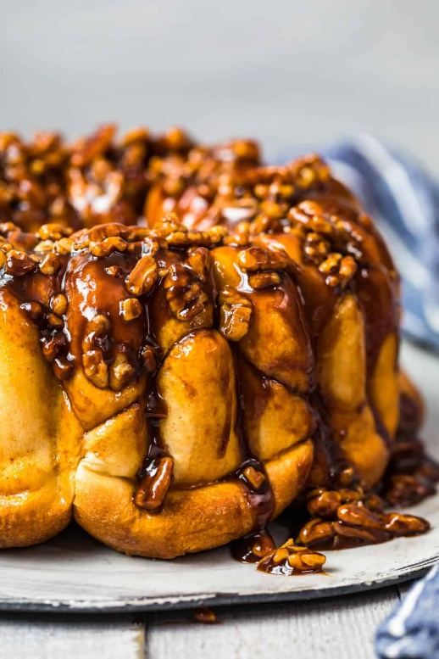**Supplies You’ll Need**

* ½ cup unsalted butter 113 grams (1 stick)
* 3.5 ounces Cook ‘n Serve Butterscotch Pudding Mix 99 grams (1 box)
* ½ cup dark brown sugar 107 grams
* ¾ teaspoon ground cinnamon
* ¼ teaspoon kosher salt
* 1 cup chopped pecans 113 grams, divided (optional)
* 24 unbaked frozen dinner rolls 912 grams

**Making the Magic Happen**

1. Generously spray a 10-inch Bundt pan with nonstick cooking spray.
2. Microwave the butter, butterscotch pudding mix, brown sugar, cinnamon, and salt on 50% power until butter has melted. Whisk together until incorporated. (½ cup unsalted butter, 3.5 ounces Cook ‘n Serve Butterscotch Pudding Mix, ½ cup dark brown sugar, ¾ teaspoon ground cinnamon, ¼ teaspoon kosher salt)
3. Sprinkle ½ cup pecans into the pan. (1 cup chopped pecans)
4. Place half the frozen rolls evenly over the pecans leaving a little space (¼-inch) between rolls. (24 unbaked frozen dinner rolls)
5. Sprinkle the remaining ½ cup pecans and ½ of the butter/pudding mixture over the rolls.
6. Add the remaining frozen rolls on top of the butter/pudding mixture (cutting the rolls where needed).
7. Top evenly with the remaining butter/pudding mixture.
8. Spray one side of plastic wrap with nonstick spray and place it loosely (sprayed-side down) over the rolls.
9. Leave the pan for 5-6 hours (on the countertop) or 8-10 hours (in the refrigerator).
10. When ready to bake, preheat oven to 350°F and bake 25-27 minutes, or until the internal temperature registers 200°F-205°F.
11. Transfer the pan to a cooling rack and cool 5 minutes.
12. Set a large plate (larger than the pan) over the rolls and invert the rolls onto the plate.
13. Serve immediately